DSP EXPERIMENTS
NAME:N.ALGIPRAN
COURSE NAME & CODE:ECA0901-DIGITAL SIGNAL PROCESSING

Expt 7 | Spectral Estimation
 | 7.1 Power Spectral Density Estimation and Spectral Analysis of Noisy Sinusoidal Signals Using Periodogram Method in MATLAB

Objectives:
- To generate a discrete-time signal consisting of sinusoidal components and noise.
- To estimate the Power Spectral Density (PSD) of the signal using the Periodogram method.
- To identify the frequency components present in the signal.
- To compare the signal power and noise power for assessing the quality of generate signal.

Procedure:
- Open MATLAB and create a new script file.
- Define the sampling frequency and number of samples.
- Generate a discrete-time signal consisting of two sinusoidal components.
- Add white Gaussian noise to the signal.
- Plot the generated signal in the time domain.
- Use the periodogram() function to estimate the PSD.
- Plot the PSD versus frequency.
- Identify the dominant frequency components from the PSD peaks.
- Analyze the spectral characteristics of the signal.
- Verify that the detected frequencies match the original signal frequencies.

Program (Matlab code):
clc; clear; close all

fs=1000; t=(0:999)/fs;
s=sin(2*pi*100*t)+0.5*sin(2*pi*200*t); n=0.3*randn(size(t));
x=s+n;

figure, plot(x), grid on

title('Signal with Noise')

figure, periodogram(x,[],[],fs) title('PSD using Periodogram')

figure X=abs(fft(x));
f=(0:length(X)-1)*fs/length(X); plot(f(1:500),X(1:500)), grid on title('Magnitude Spectrum')

figure
bar([mean(s.^2) var(n)]) set(gca,'XTickLabel',{'Signal','Noise'}) title('Power Comparison')
grid on

Output:
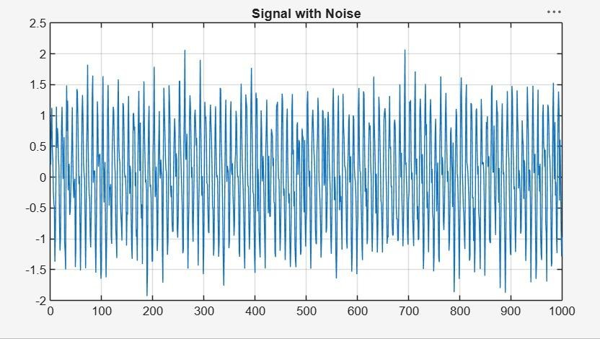

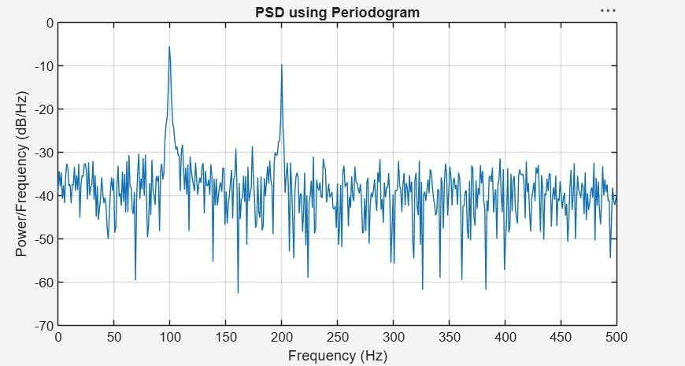
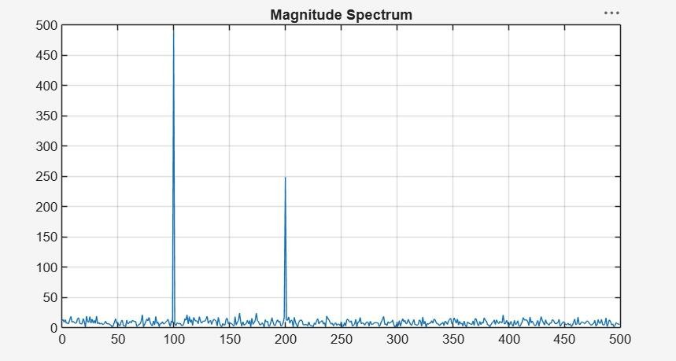

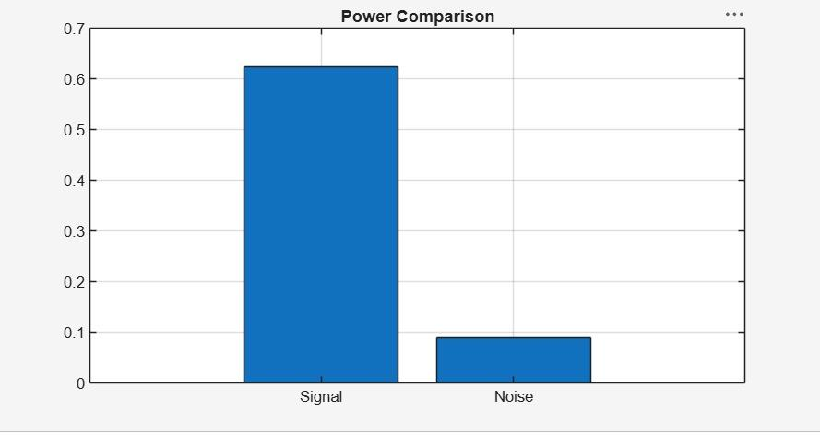

Result:
- A discrete-time signal consisting of sinusoidal components with added noise was successfully generated in MATLAB.
- The Power Spectral Density (PSD) of the signal was estimated using the Periodogram method.
- The dominant frequency components present in the signal were accurately identified from the PSD plot.
- The spectral characteristics of the signal were analyzed, showing the distribution of signal power across frequencies and the effect of noise on the spectrum.

.

Expt 7 | Spectral Estimation
Date: | 7.2 Analysis of Windowing Effects on Spectral Estimation Using Rectangular, Hamming, and Hanning Windows in MATLAB

Objectives:

  - To estimate the spectrum of a signal using different window functions such as Rectangular, Hamming, and Hanning windows.
  - To analyze the effect of window selection on spectral leakage.
  - To compare the main-lobe width and side-lobe levels of different windows.
  - To evaluate the accuracy of frequency component detection.

Procedure:

- Open MATLAB and create a new script file.
- Define the sampling frequency and number of samples.
- Generate a discrete-time signal consisting of sinusoidal frequency components.
- Apply the Rectangular window to the signal.
- Compute the FFT and estimate the spectrum.
- Repeat the process using Hamming and Hanning windows.
- Plot the spectral estimates obtained using each window.
- Compare the spectra in terms of spectral leakage, main-lobe width, and side-lobe levels.
- Observe the visibility of frequency components for each window.

Program (Matlab Code)

clc; clear; close all;

% Signal

fs = 1000; N = 256; t = (0:N-1)/fs;

x = sin(2*pi*100*t) + 0.8*sin(2*pi*110*t); NFFT = 2048; f = (0:NFFT/2-1)*(fs/NFFT);

% Windows

w = {rectwin(N), hamming(N), hann(N)}; names = {'Rectangular','Hamming','Hanning'};

% Processing for i = 1:3
xw = x(:).*w{i}; X = fft(xw,NFFT);
P{i} = abs(X(1:NFFT/2));

P{i} = P{i}/max(P{i});

end

%% Individual Spectrums figure;
for i = 1:3 subplot(3,1,i);
plot(f,20*log10(P{i}),'LineWidth',1.5); title(['Spectrum using ' names{i} ' Window']); xlim([0 250]); grid on;
end

%% Comparison figure;
plot(f,20*log10(P{1}),'k',f,20*log10(P{2}),'r',f,20*log10(P{3}),'b','LineWidth',1.5); legend(names); title('Window Comparison'); xlim([50 170]); grid on;

%% Window Shapes figure;
for i = 1:3

subplot(3,1,i); plot(w{i},'LineWidth',1.5); title([names{i} ' Window']); grid on;
end

%% Peak Detection

for i = 1:3

[pks{i},loc{i}] = findpeaks(P{i},f,'MinPeakHeight',0.3); fprintf('\n%s Window Frequencies:\n',names{i}); disp(loc{i});
end

%% Peak Marking (Hamming) figure;
plot(f,20*log10(P{2}),'LineWidth',1.5); hold on;

plot(loc{2},20*log10(pks{2}),'ro','MarkerFaceColor','r'); title('Detected Frequencies (Hamming)'); xlim([50 170]); grid on;

%% Main Peaks

fprintf('\nMain Spectral Peaks:\n'); for i = 1:3
[~,idx] = max(P{i});

fprintf('%s Window Peak = %.2f Hz\n',names{i},f(idx)); end

Output:

Rectangular Window Frequencies: 100.0977 109.8633
Hamming Window Frequencies: 100.0977 109.8633
Hanning Window Frequencies:

100.0977 109.8633

Main Spectral Peaks:

Rectangular Window Peak = 100.10 Hz Hamming Window Peak = 100.10 Hz Hanning Window Peak = 100.10 Hz
>>
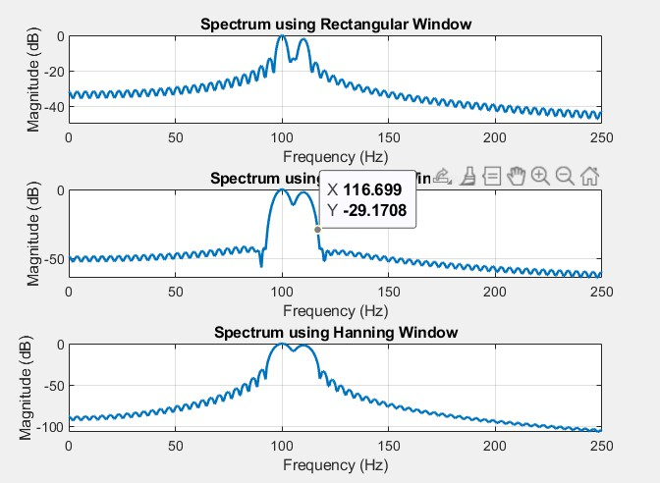
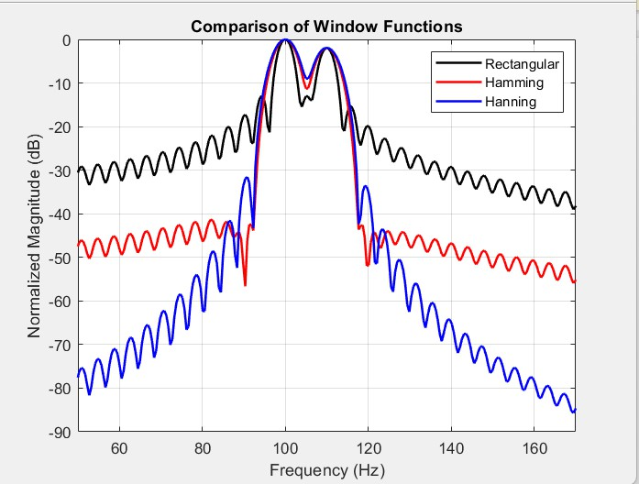

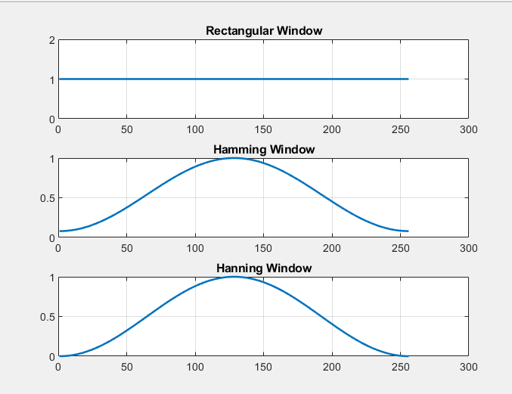

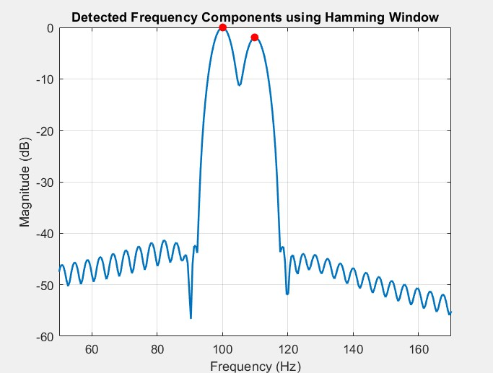

Spectrum Estimation Output
Detected Frequencies using Rectangular Window (Hz) 100.0977 109.8633
Detected Frequencies using Hamming Window (Hz) 100.0977 109.8633

Detected Frequencies using Hanning Window (Hz) 100.0977 109.8633

Result:

- The spectrum of the given signal was successfully estimated using Rectangular, Hamming, and Hanning window functions in MATLAB.
- The effect of window selection on spectral leakage was analyzed, showing that the Rectangular window exhibits higher leakage compared to Hamming and Hanning windows.
- The main-lobe width and side-lobe levels were compared, where Hamming and Hanning windows provided better side-lobe suppression at the cost of slightly wider main-lobes.
- The accuracy of frequency component detection was evaluated, and it was observed that windowing improves frequency resolution and reduces spectral distortion.

